**Archiving an Existing MOSES Database and Building a New RUSLE2 MOSES Database for Field Office use**

When significant changes have occurred in a CMZ database (and in some cases soils databases) the field office may need to build a completely new RUSLE2 database from the “base database” on the official RUSLE2 website (<http://fargo.nserl.purdue.edu/rusle2_dataweb/RUSLE2_Index.htm>) rather than importing the new updates as usual. Below are the step-by-step instructions for how to perform this task.

Archiving an Existing MOSES.gdb and Creating a New MOSES.gdb

1. Read through the entire set of instructions below at least once BEFORE embarking on this task!
2. Archive your current “moses.gdb” database that should be located in *S:\Service_Center\NRCS\RUSLE2* into the *S:\Service_Center\NRCS\RUSLE2\archives* folder that you previously created or will create. Note: if you use a laptop and maintain your “moses.gdb” on your C:\ drive, you will need to make sure that your database is synchronized with the “moses.gdb” on the server. This is important when there are multiple users in one office so that all are using the same database.
3. Rename your archived “moses.gdb” database as “moses XX-XX-20XX.gdb” where XX-XX-20XX is the date which you archived your database so that it will not get overwritten the next time you archive the database.
4. Download the official RUSLE2 zipped base database called “BASE_NRCS_MOSES_101212.zip” or later version from <http://fargo.nserl.purdue.edu/RUSLE2_ftp/NRCS_Base_Database/> to your *S:\Service_Center\NRCS\RUSLE2* folder or C:\Program Files\USDA\Rusle2, if using a laptop.
5. Unzip the base database (i.e. right click on the file and “WinZip…extract to here”).
6. Rename the extracted database from “BASE_NRCS_MOSES_101212.gdb” or later to “moses.gdb” or another moses name you will recognize as your current working database.
7. Depending on your location, download the official RUSLE2 CMZ management database called “CMZ XX.zip” from <http://fargo.nserl.purdue.edu/RUSLE2_ftp/Crop_Management_Templates/> to your *C:\Program Files\USDA\RUSLE2\Import* folder.
8. Unzip the management database (i.e. right click on the file and “WinZip…extract to here”).
9. Download the official RUSLE2 soil database(s) for your county/counties for your state: <http://fargo.nserl.purdue.edu/rusle2_dataweb/NRCS_Soils_Data_Files.htm> to your *C:\Program Files\USDA\RUSLE2\Import* folder. Right click on county soil gdb, select Save Target As.
10. Download the official RUSLE2 latest base database updates from <http://fargo.nserl.purdue.edu/RUSLE2_ftp/NRCS_Base_Database/Latest%20Base%20Database%20Updates/> to your *C:\Program Files\USDA\RUSLE2\Import* folder.
11. Unzip the database updates (i.e. right click on the file and “WinZip…extract to here”).
12. Download the official RUSLE2 climate file for your state from <http://fargo.nserl.purdue.edu/RUSLE2_ftp/Climate_data/> .
13. Unzip the climate files (i.e. right click on the file and “WinZip…extract to here”).
14. NOW you can open the RUSLE2 program. Make sure that your default database is the “moses.gdb” that you just put in your *S:\Service_Center\NRCS\RUSLE2* folder or C:\Program Files\USDA\Rusle2 earlier. It should not have any climate, soil or management records yet.
15. Import the NEW CMZ managements from the CMZ XX.gdb file that you unzipped.
16. Import the NEW soils records from the soils database(s) that you downloaded.
17. Import the NEW database updates from the update database that you unzipped.
18. **Since some of the CMZs recently updated had significant folder structure and management name changes, state agronomists should advise users whether to import the profiles, worksheets, plans and any C-folder managements that you created from your archived database. Only attempt to import older files after checking with your state agronomist.** Make sure that you select the “None” radial button at the bottom left of the import window when importing records from your old database! Failure to select none can compromise the integrity of the database (i.e. your results may not be valid). During this last import step you may get some consistency check errors. You must fix any broken links to records that have been moved, renamed or no longer exist. If you are at all unsure how to do this click “stop checking” at the bottom of the window and call a RUSLE2 support staff or the state agronomist to help you fix the broken links BEFORE ever using RUSLE2.
19. After all of the above steps have been followed, run another consistency check on the database. As in the above step, ensure that all links are reconnected *correctly*.

Fixing Broken Links Created by Changes in the Database

* Example of a change of record name to correct previous error:

**Before After**

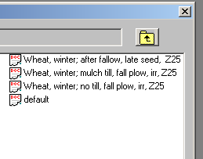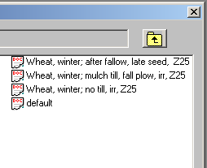

* Make sure that you run the “Check consistency” option under the “Database” menu:

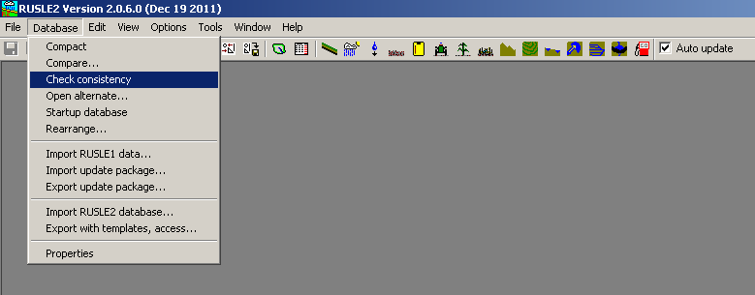

* 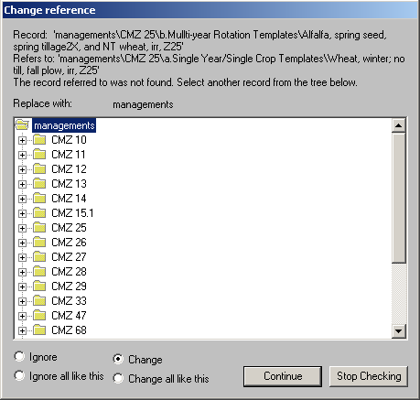You should get a warning that another record that depended on the renamed record can no longer find that record and R2 cannot complete the database without a broken link.
* 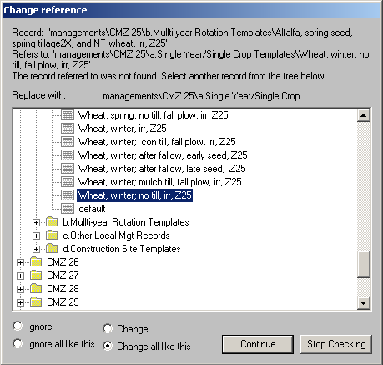You must manually reconnect the renamed record to the dependent record by selecting the new record in the database, choosing the “Change all like this” option so that all records looking for the old, deleted record will be replaced with the new, renamed record and then click “Continue”.
* Make sure that EVERY broken link is reconnected to an appropriate replacement record. If you are unsure how to correct a broken link, click “stop checking” at the bottom of the window and call a RUSLE2 support staff or the state agronomist to help you fix the broken links BEFORE ever using RUSLE2.