**How to use RUSLE2 in Permanent Crop Situations**

(e.g. orchards, vineyards, etc.)

**A REMINDER to anyone reading this document:** RUSLE2 is a program that models sheet and rill erosion in several different situations. At no time is RUSLE2 (NRCS standalone version 2.5.2.11 or older) appropriate in modeling erosion caused by concentrated flow. If your situation is such that gullies are forming, this model would most likely be underestimating actual soil loss in the area of interest. Remember, the RUSLE2 planning slope ends where deposition or concentrated flow begins.

**Introduction**

This document is intended to provide guidance for the proper use of RUSLE2 in modeling permanent crop situations. In permanent crops such as vineyards and orchards, the field can generally be described as having vine, tree or crop rows with a vegetation and management that is distinctly different than the vegetation and management between the rows of the vine, tree or crop (Figure 1.). Simply averaging the characteristics of the different vegetations and managements to represent typical erosion on these kinds of fields may not be appropriate in most situations when attempting to determine soil loss, soil conditioning index or soil tillage intensity.

**Figure 1.** This is a soon-to-be vineyard with the cover crop already seeded and the future vine rows defined by the aligned T-posts. The different management zones in the field are evident even before vine planting and indicated by the colored areas.



In situations like Figure 1. it is important that you understand all operations that happen in the field and where they happen. Then separate management records should be created to describe the alley management and the vine/tree/crop row (vine row) management. Keep in mind that all traffic usually occurs in the alleys and not the vine row. So, if you are entering an operation that kills weeds with a spray rig in the vine row, ensure that the record used does not apply traffic to the vine row, such as a “kill crop” record.

**Well Defined Scenarios**

Once the separate management records have been created, you must determine which way the water is flowing in the vineyard. Figure 2 has some conceptual sketches of four generalized water flows in a vineyard situation. Once you have determined which way the water is flowing in the vineyard according to Figure 2, proceed to model the hillslope in the manner described in the next few paragraphs.

**Figure 2.** Conceptual sketches of four generalized water flows in a vineyard situation.



*Figure 2A*

In this scenario, the vines are on the contour or close to the contour and the orientation of the vines are such that it does not divert or concentrate water flowing down the hill (i.e. no berms). For this situation use the Management Strip Builder option in RUSLE2’s **Profile View** (Figure 3) to tell RUSLE2 that you have two distinct managements on the hill slope that are on, or nearly on, the contour at systematically repeating intervals.

**Figure 3**. Screen capture of the management strip builder of the Profile View in use.

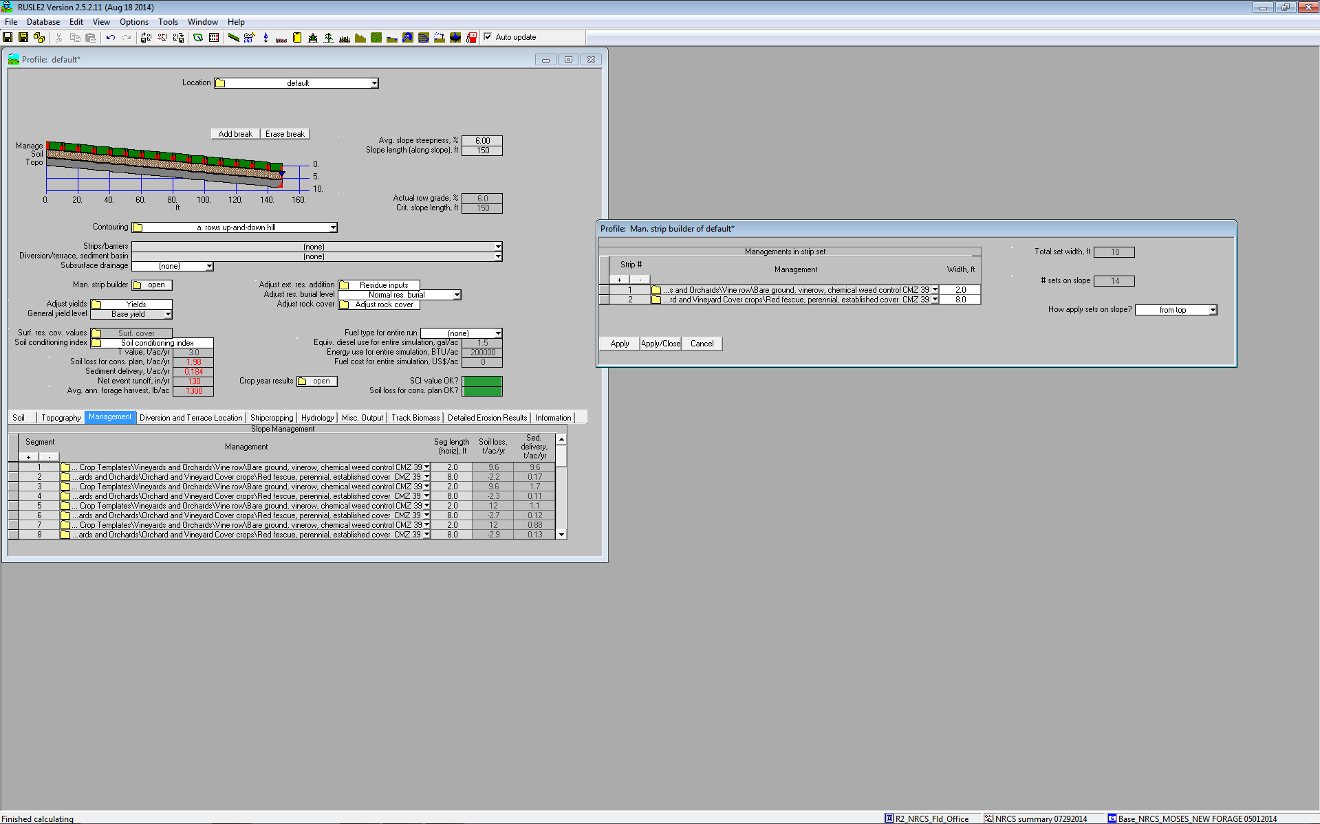

*Figure 2B*

In this scenario, the vines are on the contour or close to the contour and the orientation of the vines are such that the bermed vine rows ***divert or concentrate water*** flowing down the hill. This scenario, with bermed vine rows, should not be modeled in RUSLE2 with the full hill slope length since the berms divert and concentrate water flow. Alternatively, this scenario can be modeled for sheet and rill erosion if the modeled slope length begins at the top of one berm and ends at the point of concentrated flow just before the next lower berm. However, this technique may grossly underestimate total actual erosion in the field if significant gullying is observed on the edge of the berms. Be sure to locate the appropriate management record on the correct slope breaks when modeling this scenario in the **Profile View**.

*Figure 2C*

In this scenario, the vines are essentially oriented up and down the slope with no berms in the vine row that could divert surface water flow in any manner. The appropriate way to model this scenario is to enter all the necessary information in the **Profile View and** when it comes time to select a management, select the vine row management and save the profile. Then, change the management and select the alley management and save the profile with another name. At this point, open the **Plan View** and select the “Compute avg. soil loss for a field/watershed”. Call in the profiles that you just created and in the far right column of the worksheet in the “Compute avg. soil loss for a field/watershed” tab, enter the percent area associated with each profile (Figure 4). For example, for a vineyard whose vine rows are space ten feet apart and the vegetated alley is maintained at a minimum width of seven feet, the ratio would be 30% vine row and 70% alley management. In situations like this, the SCI and STIR should be calculated manually until the profile view can be edited in the future for this type of situation. Calculate SCI and STIR by doing a weighted average in the same way that RUSLE2 calculates the reported average soil loss values.

**Figure 4**. Screen capture of the Plan View in use for determining soil loss in a vineyard/orchard with the vine/tree rows oriented up-and-down the hill slope.

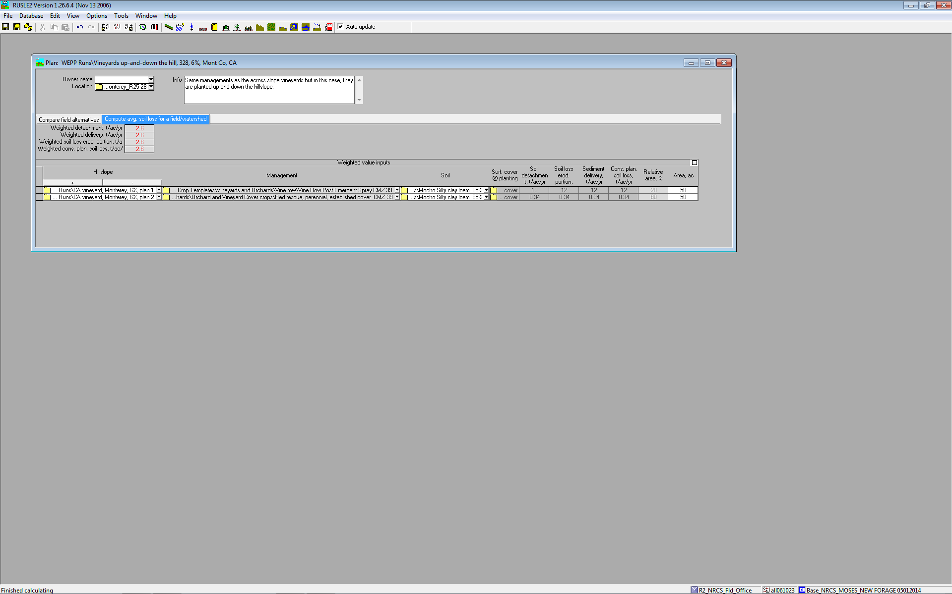

*Figure 2D*

In this scenario, the vines are essentially oriented up and down the slope with berms in the vine row that divert surface water flow away from the vines and into the adjacent vegetated alley. The appropriate way to model this situation is to determine a representative slope that captures the path of water flow from the top of the vine row berm, follows it as the water flow down the edge of the berm at some oblique angle down to the flatter, vegetated alley and then continues down the vegetated alley. Once this representative slope has been determined, the information can be entered into the **Profile View**. Be sure to locate the appropriate management record on the correct slope breaks when modeling this scenario.

**Grey Areas**

Figure 5 illustrates a scenario that is somewhere between scenarios 2A and 2C above. In this situation, the vine rows are oriented at some angle off of perfect contour, usually more than 10% of the hill slope grade, and there are no berms. However, due to the steepness of the vine row/alley grade and the abrupt change in vegetation management, the overland water flow can sometimes be intercepted by the edge of the vegetated alley and then diverted alongside the vegetation. This concentration of flow must be identified in the field. If this situation is prevalent in the field, model the field in a manner consistent with scenario 2B above. If this situation is more the exception in the field rather than typical, then model the field in a manner consistent with scenario 2A above.

**Figure 5.** Interrupted surface flows on an otherwise smooth topographic feature.



**California and possibly other limited areas**

For permanent crops (e.g. vineyard and orchards) in California the field conditions are such that usually, the crop is dormant during the rainy season and is actively growing during California’s dry season. Additionally in vineyards, the vine row is usually kept bare during the growing season and the alleys are usually vegetated. Because of these management differences, we should model these situations in RUSLE2 as bare soil with some degree of weed control (during the early part of the year) for the vine row and as a managed vegetative cover for the alleys. This approach essentially ignores the vine growth but, from an erosion perspective, it is a reasonable simplification. The organic material that is produced (i.e. leaves and prunings) and returned to the system can be modeled as external residue added to the alley or vine row, depending on management style, in the appropriate RUSLE2 record.