Answer all these questions and then input values into RUSLE2 to get the MOST ACCURATE results from RUSLE2 for soil loss, SCI and STIR. Answer N/A to questions that do not apply to your client’s situation.

**General Questions:** Questions are referenced on Figure 1

1. What is the total average annual rainfall at the location you are modeling? _____
2. Is the crop planted up-and-down the slope, on the contour or off contour at some degree (i.e., what is the row grade)? __________________________
3. If the slope is consistent for the entire length of the surface water flow (i.e. the RUSLE2 transect) what is the length and % slope? ______________________ [Use this option for general conservation planning.]

|  |  |  |
| --- | --- | --- |
| segment | Length (ft) | % slope |
| 1 |  |  |
| 2 |  |  |
| 3 |  |  |
| 4 |  |  |
| 5 |  |  |
| 6 |  |  |
| etc. |  |  |

1. If the slope is complex, what are the lengths and % slope for each component segment of the entire RUSLE2 transect? [Use this option for modeling of filter strip design or water quality purposes
2. What is the dominant, critical soil type in the field along the transect that you are modeling? _________________________ [Use this option for general cons. planning.]
3. If there are significant amounts of distinctly different soil types along the transect then what are they and where are they located on the slope?

|  |  |  |
| --- | --- | --- |
| segment | Length (ft) | Soil type |
| 1 |  |  |
| 2 |  |  |
| 3 |  |  |
| 4 |  |  |
| 5 |  |  |
| 6 |  |  |
| etc. |  |  |

1. What is the rotation that the grower follows? ___________________________________

_______________________________________________________________________

**Management Questions:** Select the RUSLE2 management template that best describes the client’s crop or rotation and check each line of the record you selected and answer the following question. Questions are referenced on Figure 2.

1. Are the dates of the selected operations correct? ________ If not, make it so. *\*\**
2. Are the operations selected in the correct order? ________ If not, make it so. *\*\**
3. Are the operations selected correct? ________ Check information by clicking the yellow folders for details. What you are looking for here is that, for example, if a farmer is using a “tandem disk” ensure that the implement operation depth and residue burial value observed in the field operation is the same as that stated in the “tandem disk” record you choose from the RUSLE2 database. *\*\**
4. Is/are the correct vegetation(s) selected? ________ (see 6. for more detail) *\*\**
5. Is/are the yield(s) reported in the RUSLE2vegetation record and the field yield consistent? _______*\*\**
6. Is the correct vegetation record selected? _______ This can be checked by graphing the %canopy of the vegetation selected and matching it up with the vegetation in the field. *Note: vegetation records have a % canopy value for each day of the record and an associated total yield value. Changing the yield value will change canopy values.* *\*\**
7. Is the field irrigated? ___________ If yes, enter irrigation information in the management record if you are modeling an irrigated crop.
8. If external residues (e.g. manure, mulch, compost, etc.) are being applied, what rate is it being applied and when (i.e. which crop(s))? ____________T/Ac.

***\*\*Note: If you are looking at a “Single year/Single Crop Template” management record, save any changes you make to the record by selecting “Save as” into the c. folder and name the modified record appropriately. If you are looking at a “Multiyear Rotation Template” then, open the appropriate component “Single year/Single Crop Template” records, edit and save as above then, follow the rotation builder instructions to build a new rotation that describes what the client is doing.***

**Details, details, details…** RUSLE2 is more accurate than any previous manifestation (i.e. USLE or RUSLE1.XX) of the model. Part of the reason it is more accurate is that the science is better and the other part of the reason is that more information is used to calculate soil loss. More information, of course, means YOU need to put the information in. Do not consider this additional information as “non-essential”. In fact, this additional information is what ensures the program’s accuracy for your client. Answer the following questions to the best of your and your client’s knowledge. Questions are referenced on Figures 3-5.

1. In conservation planning, it may be beneficial to see the effects of adding a buffer strips, filter strips or vegetative barriers to the field. This can be done be selecting the appropriate vegetative strip/barrier from the “Strips/barriers” drop-down menu. If a strip/barrier already exists in the field that you are modeling and it does not match up with the options in the “Strips/barriers” drop-down menu, then manually insert the strip/barrier into the management layer of the graphic or the management tab in the summary view of the Profile screen. (Figure 3)
2. Again, in conservation planning, it may be beneficial to see the effects of adding a diversion, terrace or sediment basin to the field. This can be done be selecting the appropriate practice from the “Diversion/terrace, sediment basin” drop-down menu. If a diversion, terrace or sediment basin already exists in the field that you are modeling and it does not match up with the options in the “Diversion/terrace, sediment basin” drop-down menu, then remember that the slope length will end where concentrated flow begins which is at the diversion, terrace or ditch feeding the sediment basin. (Figure 3)
3. Is there subsurface drainage in the field? _________ (Figure 3)
4. If there is exposed rock at the soil surface, what percent of the surface is covered with rock? ______________ Use the line-intercept method to determine this value as you would residue cover. (Figure 3)
5. Check the values for Live Biomass and Surface Residue Cover and ensure that these are consistent with observed field values. Are they consistent? _________ If not you may need to adjust yields, change vegetation records or modify other parameters. (Figure 4)
6. Enter irrigation/wind induced erosion values in the SCI folder to get the SCI value for the field you are modeling. (Figure 5)

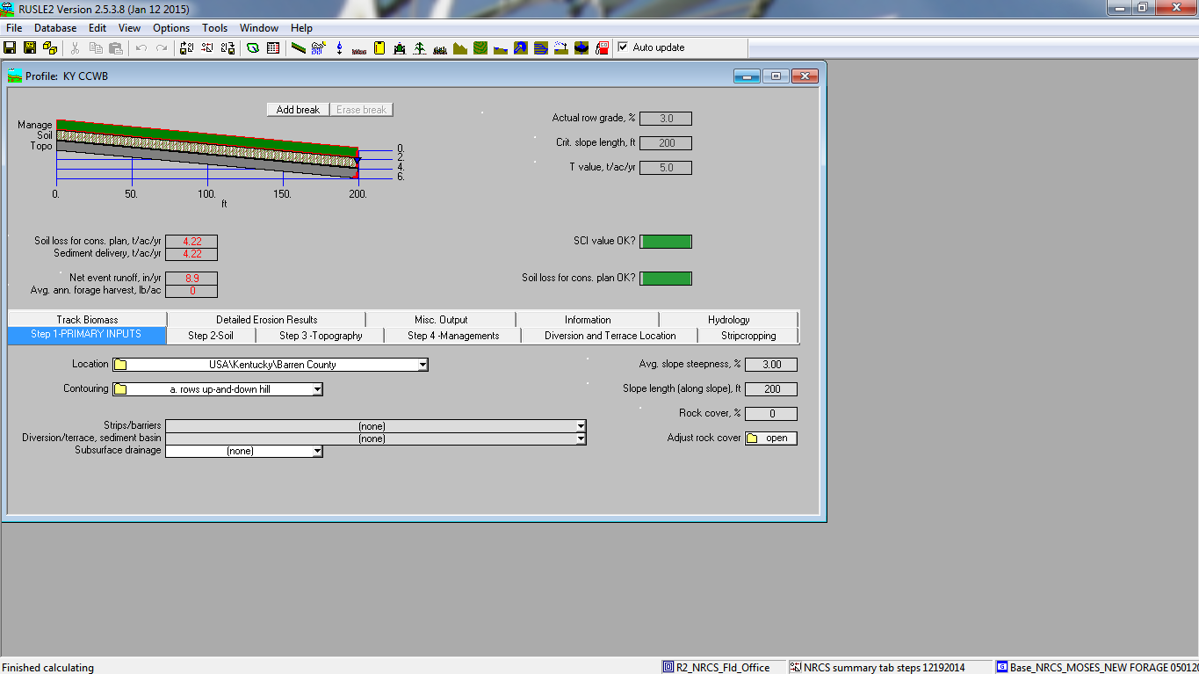

**G5**

**G6**

**G2**

**G1**

**G3**

**G7**

**G4**

**Figure 1**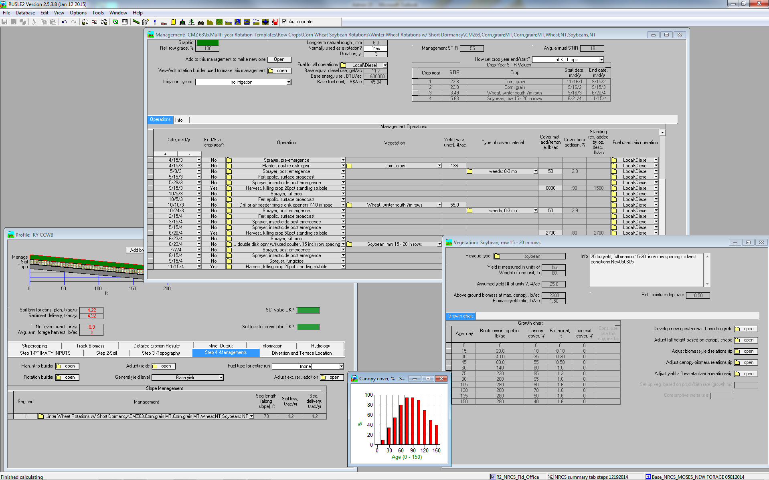

**Figure 2**

**M6**

**M6**

**M8**

**M7**

**M4**

**M2**

**M3**

**M1**

**M5**



**D4**

**D1**

**D3**

**D2**

**Figure 3**

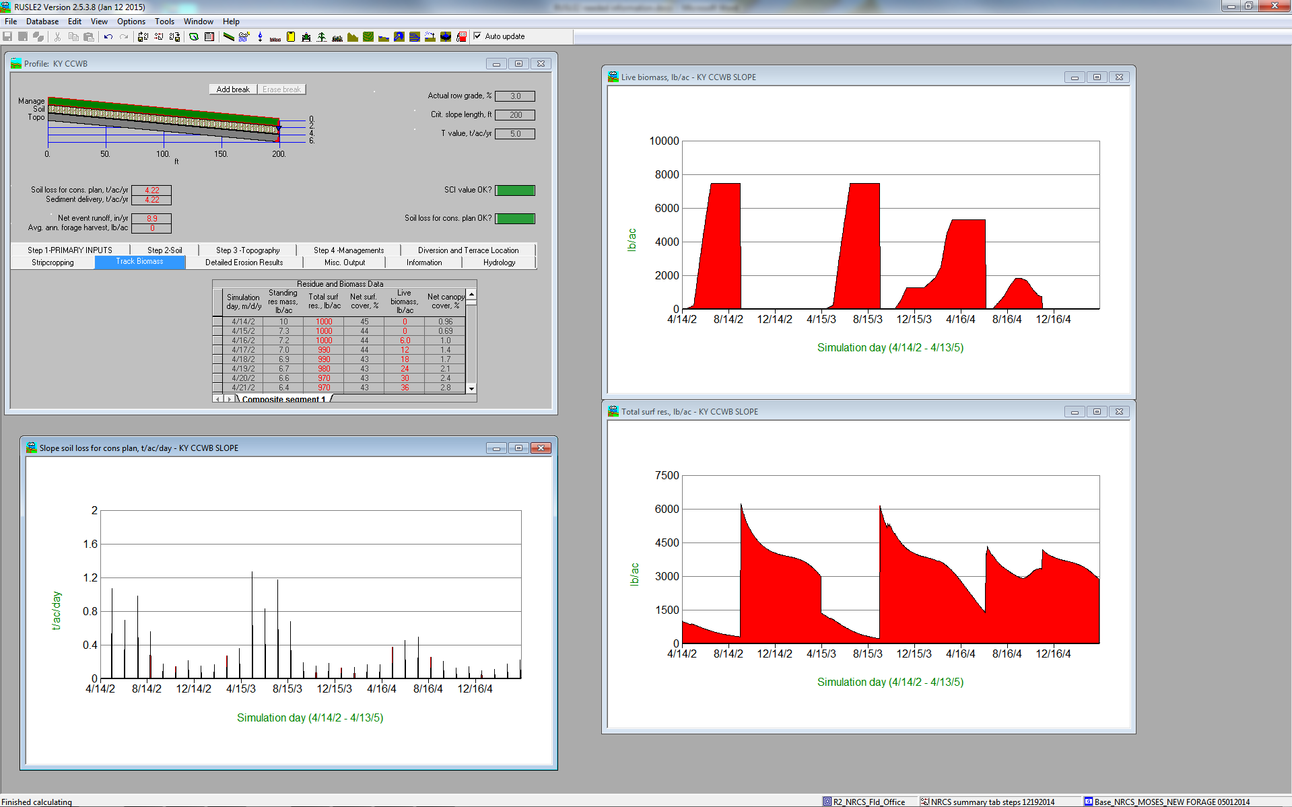

**D5**

**D5**

**D5**

**Figure 4**

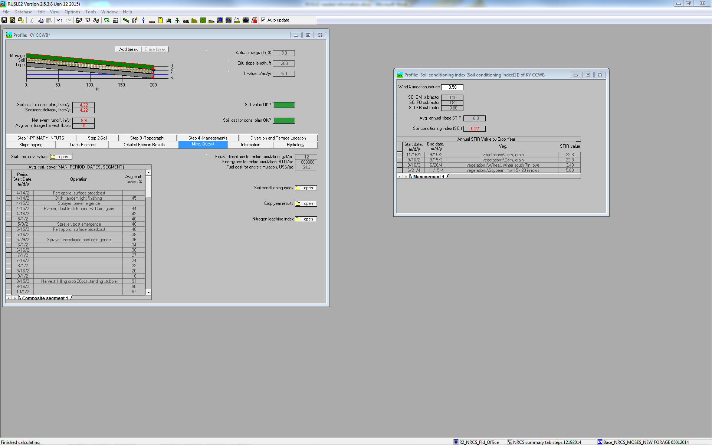

**D6**

**Figure 5**