**RUSLE2 (version 2.5.2.11 and 2.5.9.0)**

As with the previous version of RUSLE2 (version 1.25.6.4), you can still calculate soil loss though the profile, worksheet and plan views. There are a few new things about RUSLE2 (version 2.5.2.11 and 2.5.9.0) that you will find are a bit different though:

1. The new version installs in a similar location (C:\Program Files (x86)\USDA\Rusle2\NRCS) to the old location (C:\Program Files (x86)\USDA\Rusle2). The additional NRCS folder level is to distinguish your officially installed version from the research version (which would be installed in the ARS folder). NOONE should be using any version for conservation planning except for the official latest NRCS release (in this case 2.5.9.0).
2. 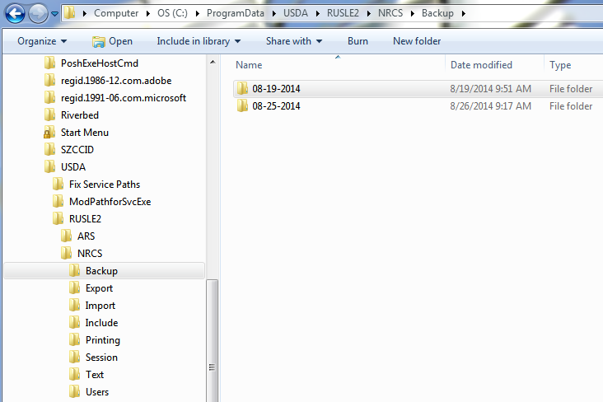During the installation process, any local “moses.gdb” will be saved in the C:\ProgramData\USDA\RUSLE2\NRCS\Backup location under a folder with the date of installation. Check here for your old moses database:
3. **Managements** have a slightly new look! We have added parameters for Crop Year results. Crop Year is defined as the period from the harvest of the last crop to the harvest of the current crop. This is important in determining which crop to attribute soil disturbance with and to calculate if a crop meets the 329 STIR requirements. The new view looks like:

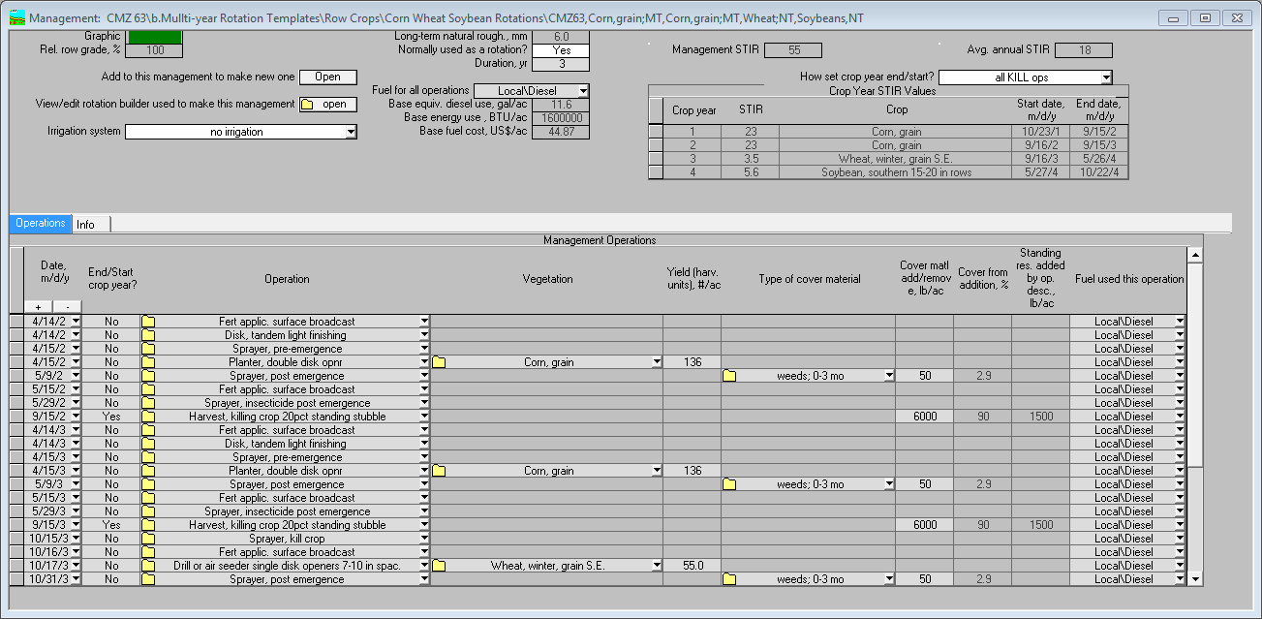

The letter A in the figure above indicates the total STIR for the entire management (in this case a 3 year rotation), the letter B indicates the average annual STIR for the rotation, letter C indicates how RUSLE2 determined the dates for determining the Crop Year Interval and the letter D indicates the Crop Year STIR results for each crop in the rotation. Letter E marks the column that the user will use to manually set the start and stop dates for calculating the Crop Year Interval. This is necessary in some cases where RUSLE2 will sometimes erroneously consider weed growth and cover crops their own interval and this must be overridden by the user to meet the definition of the interval from harvest of the previous crop to the harvest of the current crop.

1. **Profiles** have some new outputs and function too! The letter A in the figure below indicates whether the SCI is above 0.2 (box is green), below -0.2 (box is red) or somewhere in the -0.2 to 0.2 region (box is yellow). The letter B indicates whether the “Soil loss for conservation planning” is below T (box is green), between T and 2T (box is yellow) or is greater than 2T (box is red). The letter C indicates the amount of runoff expected from the modelled run and the letter D indicates the amount of forage harvest (average annual) results when using the new-style perennial vegetations. Letter E marks the Crop Year Results window that is for the user to view and to manually set the start and stop dates for calculating the Crop Year Interval. More on the details of the Crop Year Results window on the next page.

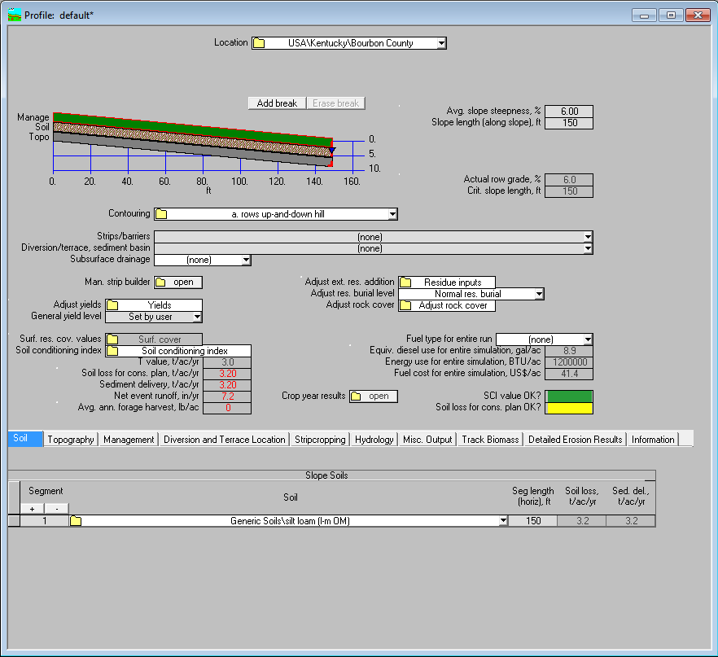

1. **Crop Year Results**. The letter A in the figure below indicates how RUSLE2 determined the dates for determining the Crop Year Interval the total STIR for the entire management (in this case a 3 year rotation), the letter B marks the column that the user will use to manually set the start and stop dates for calculating the Crop Year Interval. This is necessary in some cases where RUSLE2 will sometimes erroneously consider weed growth and cover crops their own interval and this must be overridden by the user to meet the definition of the interval from harvest of the previous crop to the harvest of the current crop. The letter C indicates the Crop Year STIR results for each crop in the rotation, letter D indicates the amount of forage harvest (average annual) results when using the new-style perennial vegetations, the letter E indicates the amount of shortfall for grazing when using the new-style perennial vegetations, and the letter F indicates a place for additional results that will be added in the next upgrade to RUSLE2 that will include Soil Loss and Sediment delivery values per Crop Year Interval.

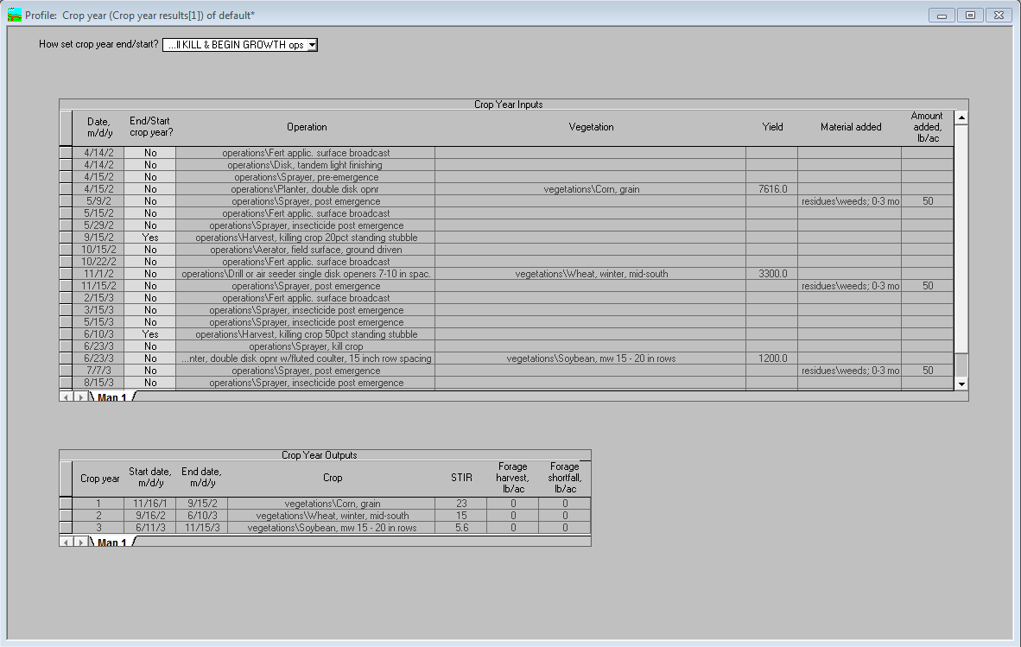

1. New Tab in the **Profile** view called Hydrology. This tab allows the user to view the runoff events for your run.

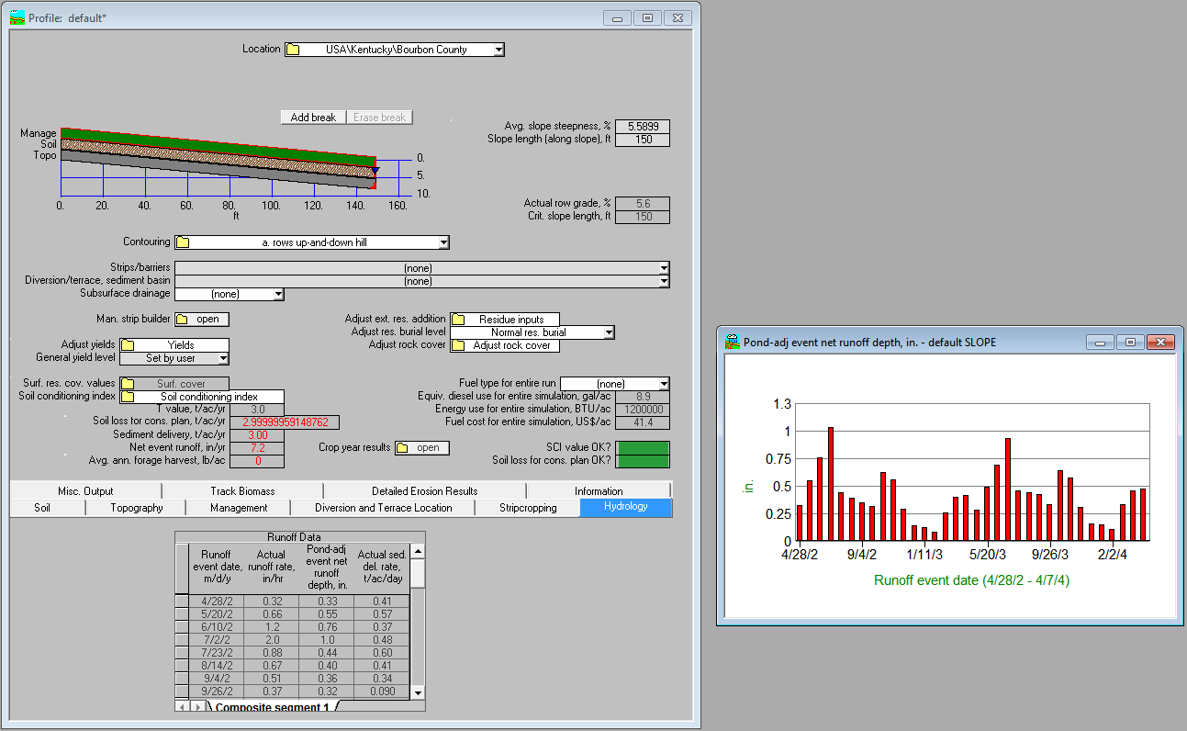

1. New tab in the **Profile** called Detailed Erosion Results. This tab allows the user to identify periods of high erosion.

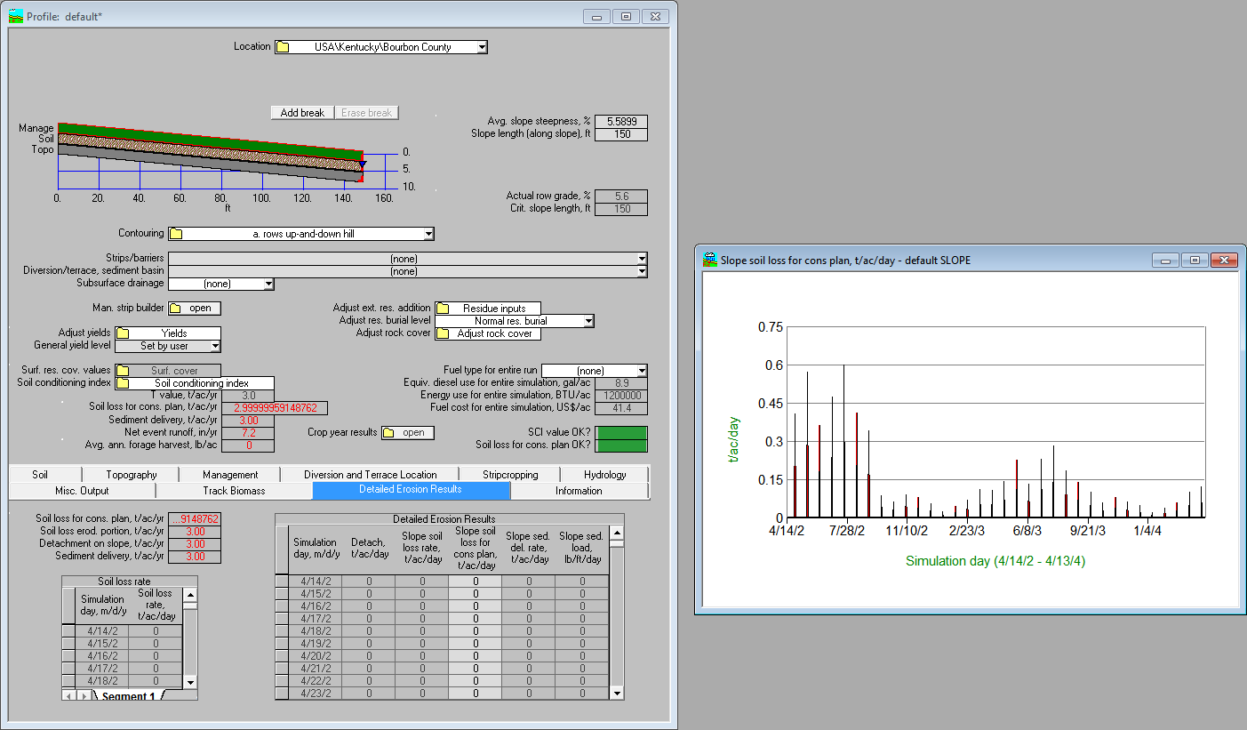

1. New **vegetations** are out in the database and are associated with a climate location within a forage production zone. The new version of RUSLE2 is capable of tracking two live vegetations at the same time and allows newly created perennial vegetations to senesce older leaves into standing residue while still growing newer leaves. CMZ leads will be working with their regional agronomists and Linda Scheffe to finalize the new forage managements associated with the new forage management zones. These will then be posted by CMZ.

